MHAA-USNR System

A Dynamic Website for Alumni Association

**By team**

Antivirus

*MHAA-USNR System*

*System Requirements Specification (SRS)*

*Document*

|  |  |  |
| --- | --- | --- |
| **Team Members** | **Course** | **Instructor** |
| Shada Khanneh | CSIT 515  Software Engineering and Reliability | Dr. Hubert A. Johnson |
| Aseel Aloweiwi |
| Mira Boulos |
| Iman Almutairi |
| Amal Alamri |

October 5, 2020

Excepted Deliverables Dates

|  |  |
| --- | --- |
| **Date** | **Deliverable** |
| 09/21/2020 | Requirement Elicitation |
| 09/28/2020 | Use Case Model and SRS Document |
| 10/05/2020 | Realization and Activity Diagram |
| 10/19/2020 | Detailed Design Specification and Design Document |
| 10/26/2020 | Implementation Tools, Technologies and Documentation |
| 11/02/2020 | Test Plan and Test Cases |
| 11/09/2020 | Testing and Testing Report |
| 11/16/2020 | Acceptance Testing |
| 11/23/2020 | User Manual |
| 12/07/2020 | Deliver Final Project and Release Notes |

Document Revision History

|  |  |  |  |
| --- | --- | --- | --- |
| **Name** | **Date** | **Reason for Changes** | **Version** |
| Shada Khanneh  Aseel Aloweiwi  Mira Boulos  Iman Almutairi  Amal Alamri | October 5, 2020 | First Release | 1.0 |
| Shada Khanneh  Aseel Aloweiwi  Mira Boulos  Iman Almutairi  Amal Alamri | November 2, 2020 | Updated Release Based on a Change Request | 2.0 |
| Aseel Aloweiwi | November 5, 2020 | Review | 2.1 |
| Mira Boulos | November 5, 2020 | Review | 2.2 |
| Shada Khanneh | November 5, 2020 | Format and Proofing | 2.3 |
| Shada Khanneh | December 12, 2020 | Enhancements | 2.5 |
| Aseel Aloweiwi | December 13,2020 | Review | 2.6 |

Table of Contents

2 Introduction 4

2.1 Purpose of the System 4

2.2 Project Goals 4

2.3 Purpose of the Current Document 4

4 Assumptions 4

5 General Requirements Specification 5

6 Functional Requirements 5

6.1 Use-Case diagram 6

6.2 Launch 7

6.3 System pages 7

6.3.1 Homepage 7

6.3.2 History 7

6.3.3 Alumni News Page 7

6.3.4 Events Page 8

6.3.5 Officers 9

6.3.6 Donations 9

6.3.7 FAQs 9

7 Non-Functional Requirements 10

7.1 Compatibility 10

7.2 Reliability and Efficiency 10

7.3 Availability 10

7.4 Interface 10

8 Maintenance and Support 10

9 Documentation and Training 10

10 Organizational Impact 11

11 Operation and Environment 11

12 Security 11

# Introduction

“MHAA-USNR” system is a dynamic website that will be designed and built to serve the needs of the Maggotty High Alumni Association - US Northern Region. The “MHAA-USNR” website will aim to facilitate the Association’s targeted objectives and provide the website’s visitors/users with an easy and simple way to benefit from the organization’s offered services.

## Purpose of the System

The Maggotty High Alumni Association website will be available for public use through the web interface. Users will be updated of the school’s news, register in events, and make donations. A specific Maggotty High School Alumni, which are called officers will have the control over the system. Officers will be able to create events and update school news. The system promises to deliver its users an easy payment and donation process via offering most known payment methods (credit cards, debit card and PayPal). The website will also display a background history of the school and how the donations contribute to develop a better learning environment.

## Project Goals

This project aims to offer a user-friendly website that will enable its users to easily navigate through the website and utilize the provided features of the system such as event registration and fund donations. Another goal of this project is to offer the school’s officers the ability to create events and add news.

## Purpose of the Current Document

This document states what functionalities the “MHAA-USNR” system will offer to its users. This document will also specify the targeted users of the system, their roles and what each user can access. The MHAA-USNR system promises to provide all the functionalities stated in this document, and not any additional features.

Terms

For a list of terms please refer to the glossary in appendix [A].

# Assumptions

* The website’s publishing cost will be the responsibility of the Client. This includes:
* Selecting and purchasing a Domain Name for the website.
* Selecting a web Hosting service to publish the website.
* Uploading the files of “MHAA-USNR” system to the webserver.
* Database interface with the “MHAA-USNR” system and files upload to webserver, will also be the client’s responsibility.

# General Requirements Specification

|  |  |  |
| --- | --- | --- |
| **ID** | **Requirement** | **Description** |
|  | Language | System interface will support English language only. |
|  | Input language | Available input text fields throughout the system will support all languages. |
|  | Error messages | * All error messages display method will be unified across the system. * All error message will indicate error cause. |
|  | Color Scheme | School colors: beige, burgundy and gold will be reflected on the website pages and maintained from one page to the next. |
|  | Navigation | * A navigation menu will be reflected in all the website’s pages. * The menu choices will remain consistent from page to page. * The user will be able to click on the menu tabs and navigate to the corresponding page. * The navigation menu choices will be: Homepage, History, Alumni News, Events, Officers and Donations. * A list of the system’s navigation links will be added at the bottom section of each page on the website as hyperlinks. * The bottom section will also reflect a Contact Us title that includes the association’s: Phone number, Email and Location information. * The bottom section will also reflect FAQs link, this link will direct the users to a page where they can find Question and Answers for common inquires. |

# Functional Requirements

In this functional requirement section, the document covers all the functionalities and procedures the “MHAA-USNR” system will perform. The system will not cover any other functions and/or features that are not described in this section.

## Use-Case diagram

The below Use-Case diagram illustrates the functionalities that will be incorporated into the MHAA-USNR system.

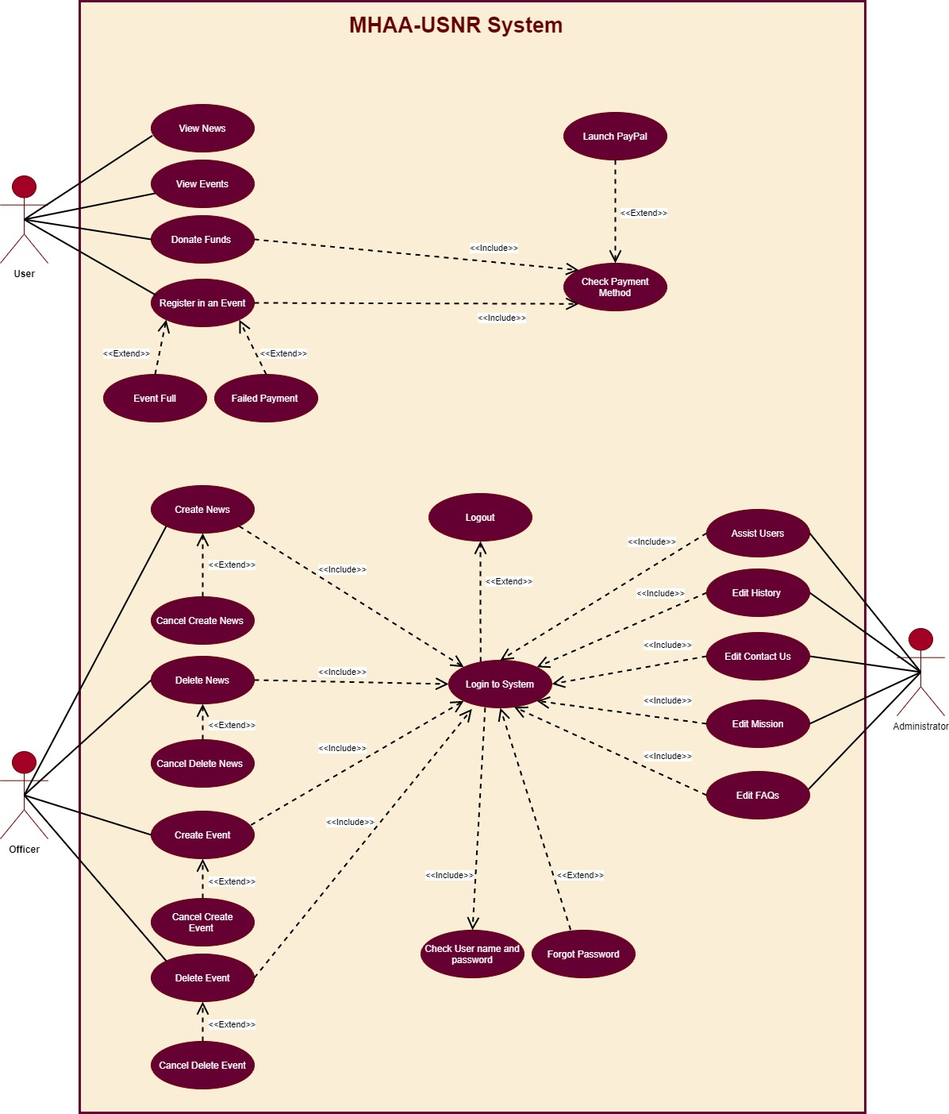

Figure MHAA-USNR System Use-Case Diagram

## Launch

The website will be accessed using the website URL. Upon entering the URL, the system will perform the following operations:

* Users will be directed to the main page.
* When a lost connection to the network is retrieved, new data will be available only upon refresh.

## System pages

### Homepage

* The Homepage will be the primary access point to the website. Upon clicking/entering the website’s URL users will be directed to the Homepage.
* The Homepage will be accessible via the navigation menu and/or the bottom section.
* The Homepage will contain a welcome message along with a description about the Alumni Association mission and motto.
* The administrator will be given the ability to edit and add to this text.

### History

* The History Page will be accessible via the navigation menu and/or the bottom section.
* Users will be able to view a description about the Alumni Association history.
* The Administrator will have the permission to edit the History information.

### Alumni News Page

The Alumni News Page will be accessible via the navigation menu and/or the bottom section. If the association wish to post and share any News or announcements they will have the ability to do so in this page. This page will also reflect the titles of these News for visitors and users to view when they navigate to this page.

* The Alumni News page will show up to 5 records of any News the association wish to share with its visitors.
* Each News record on this page will show the corresponding News title, date and a thumbnail.
* Users will be able to click on a specific News title to view additional information and images about the News.
* Officers will be able to add and delete a News record.
* Officers will be able to upload images to the News record. The uploaded images must not exceed 5 MB/image and the size of all images on the News page must not exceed 1 GB.

### Events Page

The Events Page will be accessible via the navigation menu and/or the bottom section. This page will include two main subtitles which are Upcoming-Events and Previous-Events. If the association wish to post and share any Upcoming-Events for users/visitors to view and/or register in, they will have the ability to do so in this page. In addition, Officers can also add information and images regarding past events.

#### Upcoming-Events

* The Upcoming-Events subtitle will include under it up to 5 records of any Upcoming-Event the association wish to share with its visitors.
* Each Upcoming-Event record on this page will show the corresponding Event title, date and a thumbnail.
* Users will be able to click on a specific Upcoming-Event title to view additional information and images about the event.
* Users will be able to register for events and pay the associative fee to attend these events.
* User will be able to pay the registration fee via the payments methods afford by the system (credit cards, debit, and PayPal).
* Officers will be able to add and delete an event record.
* Officers will be able to determine the event title, date, location, start time, max number of attendees and fee.
* Officers will be able to upload images to the event record. The uploaded images must not exceed 5 MB/image and all images size on the events page must not exceed 1.5 GB.

#### Previous-Events

* The Previous-Events subtitle will include under it up to 5 records of any Previous-Event the association wish to share with its visitors.
* Each Previous-Event record on this page will show the corresponding Event title, date and a thumbnail.
* Users will be able to click on a specific Previous-Event title to view additional information and images about the event.
* Officers will be able to add and delete records regarding past events.
* Officers will be able to upload images to the record. The uploaded images must not exceed 5 MB/image and all images size on the events page must not exceed 1.5 GB.

### Officers

* The Officers Page will be accessible via the navigation menu and/or the bottom section.
* This page will display each officer’s name beside his/her photo and a brief summery about each Officer.
* This page will view a login box (username and password).
* Officers will enter their credential into the login box. Once logged in, officers will be granted the following permissions:
* Ability to add and delete news.
* Ability to add and delete upcoming and previous events.

### Donations

In the Donations page users will be able to enter their information and a fund amount and post it to the association.

* The donations page will be accessible via the navigation menu and/or the bottom section.
* Users will be able to submit a payment to the association via this page.
* Users will be able to donate funds using credit cards, debit cards and PayPal.
* After a successful donation transaction is complete, the user will receive a confirmation Email that includes the receipt information and a thank you letter.

### FAQs

In the FAQs users will be able to view commonly asked questions and their corresponding answers, and quickly learn the answers to any inquires they might have regarding the website or the association.

* The FAQs page will be accessible via the bottom section of each page.
* The FAQs page will display up to 4 records of questions and answers.
* The Administrator will be able to edit the questions and answers.

# Non-Functional Requirements

## Compatibility

* Users will be able to access the system on PC platforms.
* Users will be able to access the system on PMDs using the devices browser (safari for IOS, chrome for android).
* The website will be displayed on different screens without overlapping, including mobiles and tablets.
* The website will be displayed in different screen resolutions.
* The software will operate on Google Chrome, Safari and Opera browsers.

## Reliability and Efficiency

* The website will handle up to 50 users simultaneously without any loss in performance speed.
* The website will take up to 2 seconds to view the information from a clicked link.
* The website will not save any information if any unexpected closing occurs.
* The website will work with an at least 85% reliability for a duration of at least two years on PCs and PMDs.

## Availability

* The system will be available at any given day and time except (from 6 AM – 9 AM every Saturday) for maintenance.
* The system will be available to any user with an Internet connection and the website’s URL.

## Interface

* The website will provide GUI.
* Users will interact with the system through:
* Input elements: buttons, check boxes and peripheral devices (mouse and keyboard).
* Navigation components: sliders.
* Information components: icons and text.

# Maintenance and Support

* A free system maintenance will be granted for the first year after releasing the software.
* A $15/hour fee is required for maintenance after exceeding the first year of the releasing date.

# Documentation and Training

* A user manual will be provided along with the software.
* The system source code will be delivered to the client.
* An optional choice of sending a training team for $17/hour for each member.

# Organizational Impact

* The system will facilitate the donation process to the Alumni association by 50%.
* The system will increase the association total donation income per year by 20%.
* The system will improve the events registration process and attendees tally by keeping digital records of events donations and attendance.
* The system will increase people’s awareness of the association, its mission, and events by 70%.

# Operation and Environment

* The system will reside in the organization’s environment.
* The system will need an Internet access and a database server to operate.

# Security

* All payment processing will be made in a secure channel.
* Entered Passwords’ characters will not be readable (The password will appear as asterisks).
* Passwords will be encrypted with MD5 hashing algorithms.
* Any exchanged documents between the client and Antivirus team will be private.

1. Appendix

**Glossary**

|  |  |  |
| --- | --- | --- |
| No. | Term | Definition |
|  | Administrator | Special user with advanced permission to edit and delete website content |
|  | Client | Maggotty High Alumni Association –US Northern Region |
|  | FAQs | Frequently Asked Questions |
|  | GUI | Graphical User Interface |
|  | MD5 | Message-Digest 5 |
|  | MHAA-USNR | Maggotty High Alumni Association –US Northern Region |
|  | No. | Number |
|  | Officers | Alumni Association members |
|  | PCs | Personal Computers |
|  | PMDs | Personal Mobile Devices |
|  | Req. | Requirement (Client specified) |
|  | SRS | System Requirements Specification |
|  | URL | Uniform Resource Locator |
|  | Users | Anyone with an access to the internet and the website link |
|  | Username | A unique name given to the officers to login to the system |